## 15 June, 2018

**₹1224**

## CRN1228421896

**Thanks for travelling with us, Rajesh Kumar**

**Ride Details**

**Bill Details**

**Ride Fare** ₹**1135.8**

**Taxes** ₹**89.2**

**Total Bill (rounded off) ₹1224**

## Have queries? Visit [support for this ride.](https://help.olacabs.com/support/app/launch?utm_source=invoice&amp;landing_page=bdetails&amp;category=compact&amp;booking_ref_no=1648021896)

**We've fulfilled our promise to take you to destination for pre-agreed Total Fare. Modifying the drop/route can change this fare.**

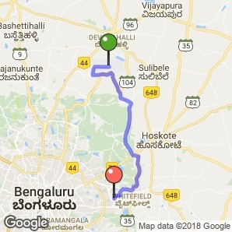

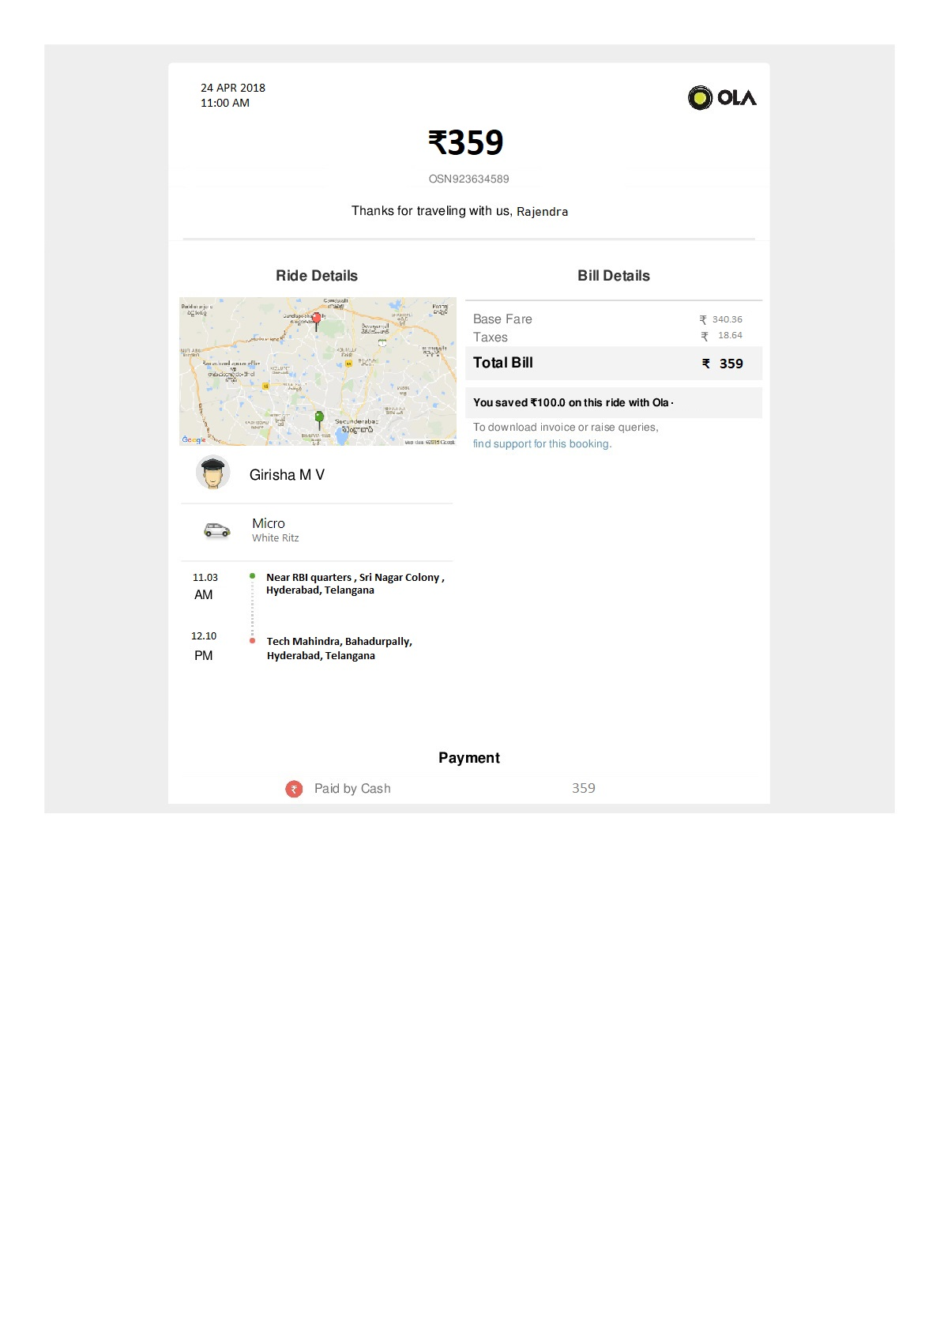

## Mini - White Dzire Tour

**04:13 AM 16 & 24, Kundalahalli,**

**Whitefield, Bengaluru**

**05:35 AM Kempegowda International Airport**

**Original Tax Invoice**

**Driver Trip Invoice**

Girisha MV , Ola Mini, Dzire Tour KA03A5433



Operator State/UT: Karnataka

Service Tax Category: Renting of motor

cab SAC Code: 936412

Invoice ID DI4FRZKYK46462 Invoice Date 15/06/2018

Customer Name Rajesh Kumar Mobile Number +918817342655 Pickup Address

**16 & 24, Kundalahalli,Whitefield, Bengaluru**

Description Amount (INR)

## Customer Ride Number - CRN1228421896

Ride Fee ₹1106.84

CGST 2.5%

SGST

2.5%

₹11.9

₹11.9

Subtotal ₹1084.63

Total

Customer Ride Fare

₹1084.63



Authorised Signatory

**Please note: 1. This invoice is issued on behalf of Transport Service Provider. ANI Technologies Private Limited acts in the capacity of an Electronic Commerce Operator as per Section 9(5) of the Central Goods & Service Tax Act, 2017 & corresponding Section 5(5) of the State GST laws. 2. This invoice has been signed by the Authorized signatory of ANI Technologies Private Limited only limited purposes of complying as an Electronic Commerce Operator.**

## Original Tax Invoice

ANI Technologies Pvt. Ltd.

5th Floor, Maruthi Infotech Center, 100 Feet Rd, Embassy Golf Links Business Park, Domlur, Bengaluru, Karnataka 560071

State GSTIN: 29AAJCA3289G1ZF

SAC Code: 999799

Service Tax Category: Business Auxiliary

Service

Invoice ID CIQFRZKIK46462 Invoice Date 15/06/2018

Customer Name Rajesh Kumar Mobile Number +918817342655 Supply Address 5th Floor, Maruthi Infotech Center, 100

Feet Rd, Embassy Golf Links Business Park, Domlur, Bengaluru, Karnataka 560071

Description Amount (INR)

Ola Convenience Fee - CRN1648021896

Convenience Fee (Ride) ₹118.96

CGST 9.0%

SGST 9.0%

₹10.71

₹10.71

Total Convenience Fee Fare

₹140.37



Authorised Signatory